CASE SCENARIO : I USED TO FOR ASSESSING CAUSALITY IS
CASE SCENARIO:
Patient name: T
Age: 39 Year
Gender: female
Weight: 62 kg
Allergy status: No known allergy
Past Medical history: BLIND SINCE BIRTH/ NO KNOWN COMORBIDITIES
Present illness: Provoked seizures-metabolic/sepsis - resolved Sepsis : blood culture :Elizabethkingia meningoseptica - resolving VAP : Acinetobacter baumanii - resolving Bronchopneumonia in ARDS - resolving. Hypocalcemia under evaluation Hypomagnesia Hypokalemia Moderate TR/PH Iron Deficiency Anemia - TSAT 9.7% Short stature with Short MCP Albright phenotype present
Past medication history: NIL
On 21/09/2026 The patient potassium level declined to 3.3 mmol/L
On 22/09/2026 The patient potassium level declined to 2.7 mmol/L
Laboratory data:
Physical examination: Blood pressure: 100/60 mmHg
HR: 104 bpm
Management:
On 22/09/2026 she was started with inj kcl 2AMP in 500 ml NS over 5 hrs
Syp potklor 15ml QID
The decreased potassium level (hypokalemia) was resolved by 25/09/2026

CAUSALITY ASSESSMENT USING NARANJO SCALE AND WHO-UMC SCALE OF CASE SCENARIO I HAVE SELECTED :
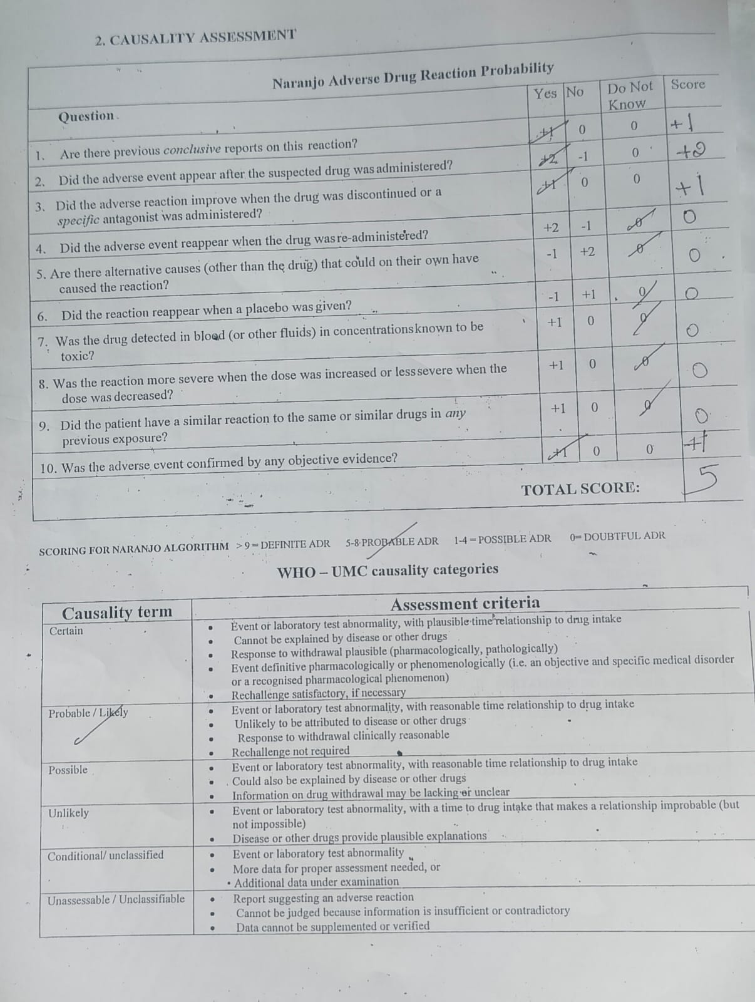

CAUSALITY ASSESSMENT USING NARANJO SCALE AND WHO-UMC SCALE OF CASE SCENARIO OF THE TUTORIAL VEDIO
